Deutsche Bank Intern Project

News Article Sentiment Analysis

Steve Zakharov1, Mikayla Malone2, Joel Jacob3, Alfred Joseph4, Emily Croxall5

1Georgia Institute of Technology 2Meredith College

3University of North Carolina - Chapel Hill 4University of North Carolina - Charlotte

5Virginia Polytechnic Institute and State University



# Overview

Our system proposes to solve the issue of wasting time reading and looking for articles about a company. We have solved this by using machine learning and web crawling to identify the sentiment of an article on a webpage via a Google Chrome extension and give the user the sentiment of the article, five related articles and their sentiments, and stock data for the given company.

# Our System

Our system is activated by Flask upon loading of a webpage. The pages URL is sent through Flask to the backend which handles text processing and sentiment analysis. Once this is complete, the information is sent back to the Google Chrome extension where it is displayed for the user.

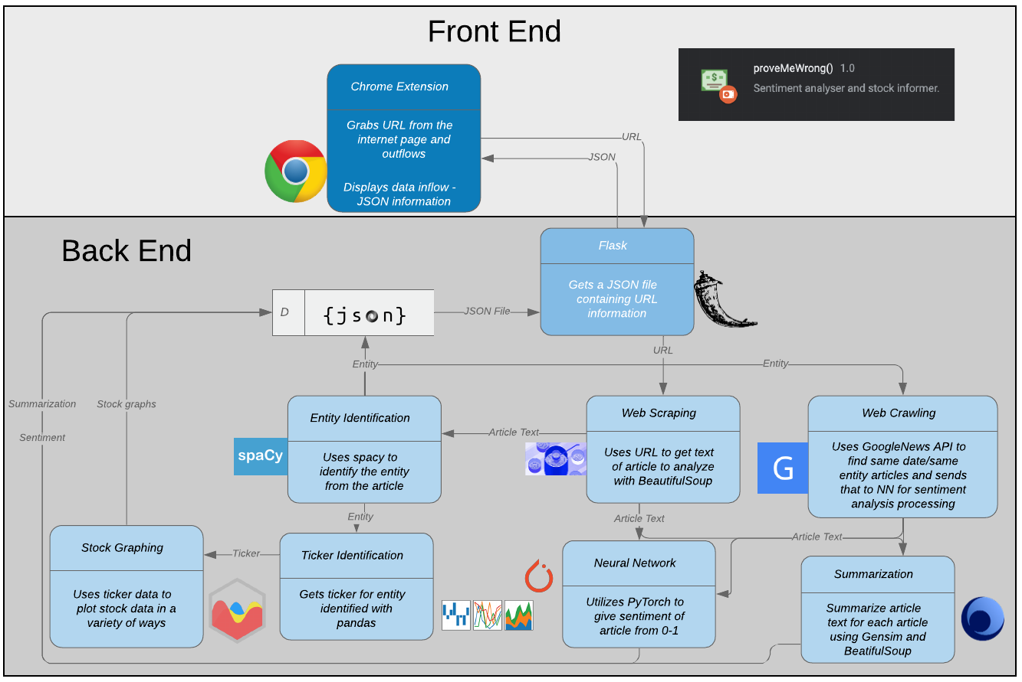

Figure . System Flow

## Machine Learning Model

The system utilizes a modern approach in the field of Natural Language Processing (NLP) combining a large dataset with a powerful machine learning tool to provide an accurate estimate of given financial news’ sentiment. If we set out the goal of this machine to accurately discriminate between positive and negative sentiments for a particular article, we need a network that has multiple inputs and only one output. The inputs must be numeric representations of the English words and the output ought to be a quantitative measurement of the article’s sentiment. Therefore, a perfect choice for the architecture of this tool could be a neural network (NN). There are many options when it comes to NN architecture. Some are tuned for recognising general patterns, while others are focused on finding narrower correlations.

An NN consists of individual units called perceptrons, loosely adapted from our understanding of the human brain’s performance.

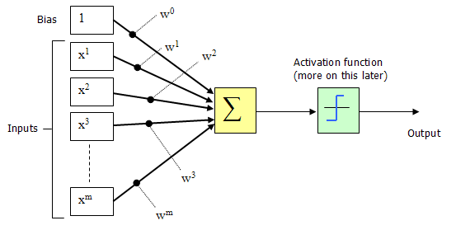

Figure 2. A perceptron model (Source: codeproject.com)

As evident from the diagram, a perceptron returns an output depending on multiple inputs. An activation function helps the perceptron to understand the threshold that the sum of the products of weights and inputs needs to reach in order for the perceptron to “fire”. Similar to the brain’s neurons, the output will switch from a 0 to a 1 on using a discrete step function or gradually change its output between 0 and 1 using a continuous sigmoid function. This is the crucial segment in understanding the functionality of the neural network, since it defines its decision boundary behaviour. The dynamic nature of the network’s weight deserves even more attention. Depending on the value of the weight, the input may become more or less significant for the neuron. This collection of weights along with the chosen architecture fully defines the NN performance.

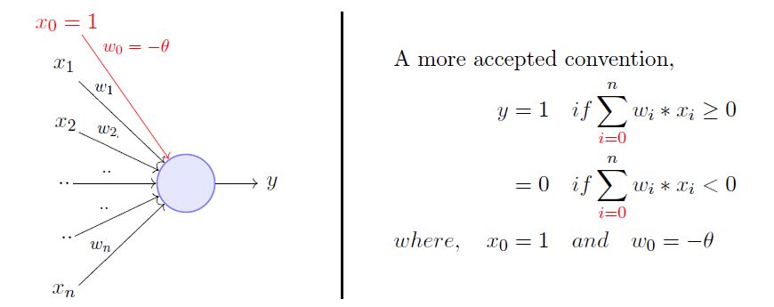

Figure 3. Source: towardsdatascience.com

Connecting these multiple perceptrons together will enable for more complex input-output relationships to be described. For most neural nets the inputs are considered independent, i.e. in calculating the loan default rates for an individual, we consider several factors, such as the customer's age, debt ratio, monthly income, etc. In this case, we can disregard the connections linking neural network inputs and use a simple ‘vanilla’ neural net. The minimum architecture consists of multiple inputs connected to an output through a series of perceptrons arranged in layers. The information is fed forward between the perceptrons through the weights.

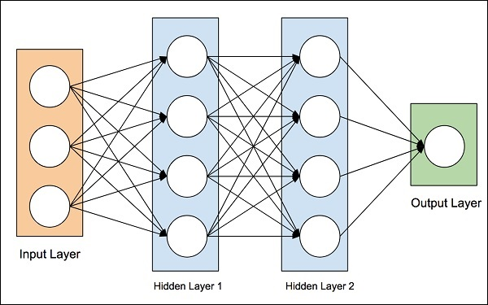

Figure 4. Source: tutorialspoint.com

However, this option has many limitations. It lacks information about how the inputs relate to each other, but in many cases the inputs are highly correlated to each other. For example, in image processing, the color of the pixel strongly depends on the colour of the surrounding pixels. For many other applications, such as image processing and, in particular, NLP, we prefer to use what is called a recurrent neural network (RNN). Through building a time sequence this approach enables us to take advantage of the known word order in the text, which very often affects the meaning of the sentence. At first, this might seem as a panacea for all the problems within the task at hand. Nevertheless, to understand the issues with this approach, we must explore the mechanism of training the neural network further.

#### Training

The training process most often involves an iterative process called stochastic gradient descent during the backpropagation stage. This process is one of the most common strategies starting with untrained models. After feeding the data forward through the network, we record our result. From the training dataset, we obtain the real result, y. Through calculating the difference between the two, we know how far away our model is from the true value. Then we add this difference to every weight in the neural network layer by layer, starting at the back and moving towards the front. During this journey of training, we alter the weights depending on the gradient of the error function. By the time we reach the beginning of the word sequence, the gradients might have completely vanished making it impossible to trace the effect of our error backpropagation. This issue is often referred to as the Vanishing Gradients problem. To better illustrate this problem, consider this sentence:

A terrible event has occurred today

We may view the primary layer of the neural net as in the following picture

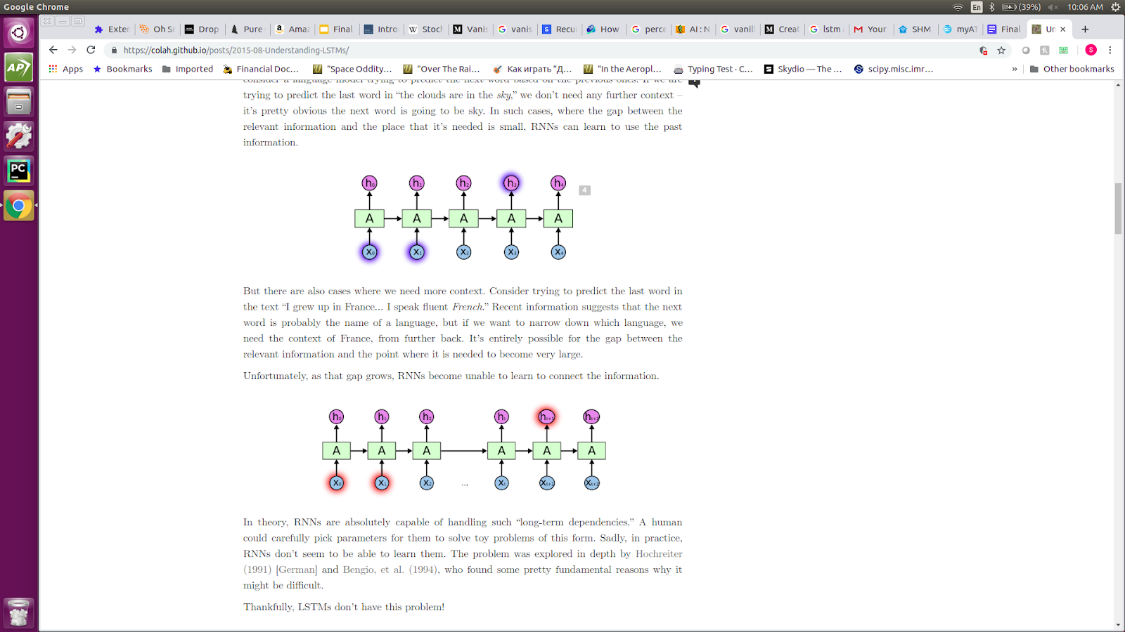

Figure 5. Source: colah.github.io

The sentiment of this statement is given as negative in the training dataset. Our network has a continuous output and is unlikely to return exactly 0, therefore we are able to calculate its error. During the training stage backpropagation is going to walk back through the time sequence and update each of the weights starting from the weight leading from a2 to a3, then continue to the weight between a1 and a2 and so on. It will update the weights according to the initial error However, if the input sequence is too long, the gradient will vanish with time to affect the earlier weights. Consider the following sentence:

A terrible event has occurred in the office of the rival company earlier today.

We can visualize this input sequence as follows:



Figure 6. Source: colah.github.io

Clearly, the word causing the most significant impact on the sentiment is still ‘terrible’, however the gradient journey may be too long for our known error to take effect on the exact weight of the NN. We will be unable to trace the effect of the known information to improve our NN, essentially making the gradients ‘vanish’.

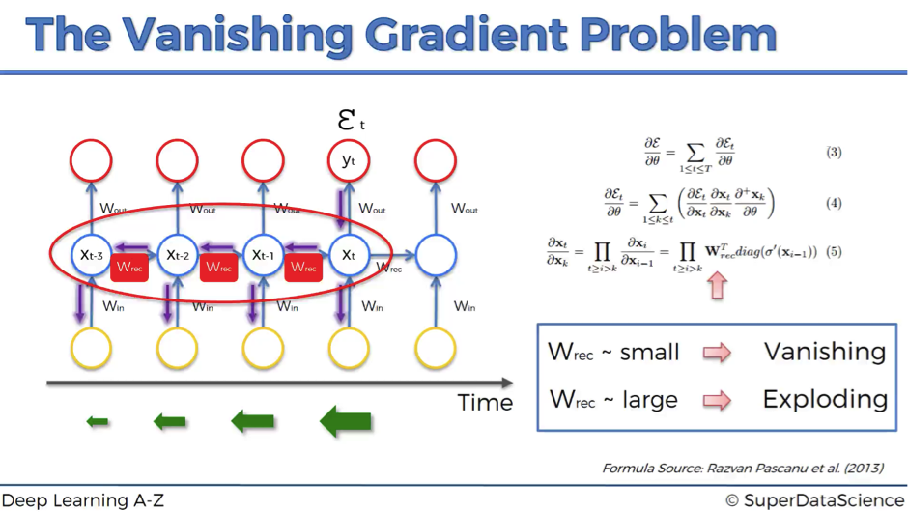

Figure 7. Source: superdatascience.com

A solution to this problem has been developed to avoid affecting the weights directly, instead passing it through conditional gates choosing whether to retain the old weights or change them according to the new information presented during training. This model is called Long Short-Term Memory network (LSTM). The name highlights the ability of such a network to save itself from potentially unnecessary changes during training or to forget its old behavior in favor of the newly learned pattern. This is enabled through transforming the previously described perceptron into an LSTM cell. This cell has one major difference called the cell state. This state can change depending on the values taken by gates within the cell. This approach has shown good performance when applied on the IMDB movie reviews dataset with 25000 data points. The inputs contain movie reviews and the output contains a binary positive / negative label. In order to transform the words into numeric inputs we used unique key identifiers which have been assigned based on most common word occurrence. The process of defining sentiment through word UIDs is called word embedding. The error graph of the training process with this model can be found below. I have completed a series of training, the lowest achieved binary cross entropy validation error was recorded to be 0.431. Below you can also find some additional training parameters. PyTorch was the library of choice for implementing the NN.

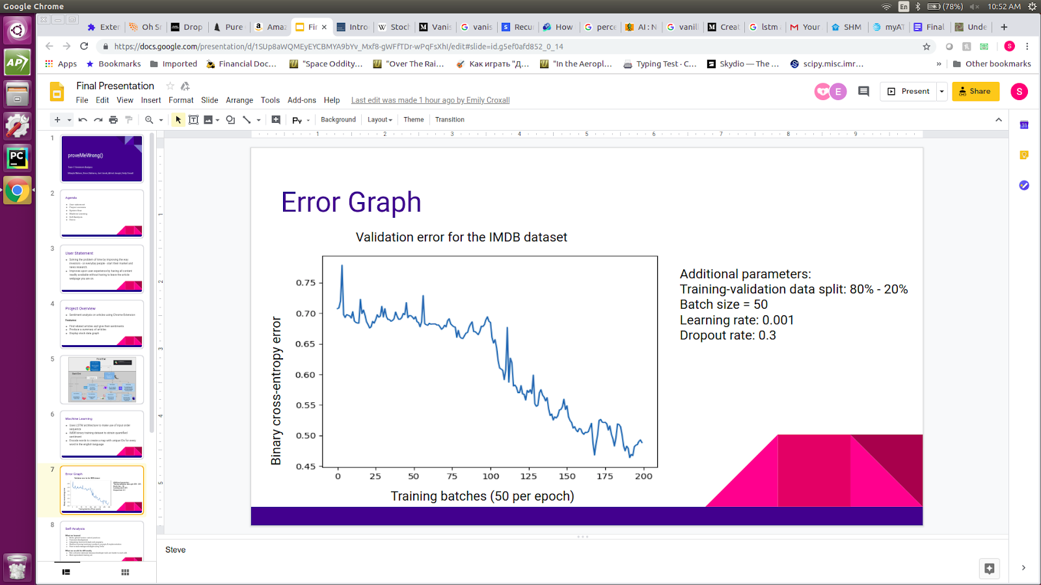

Graph 1. Validation error for the IMDB dataset.

*Table 1. Additional training parameters*

|  |  |
| --- | --- |
| Parameter | Value |
| Embedding dimension | 400 |
| Number of layers | 2 |
| Number of perceptrons per layer | 256 |
| Batch size | 50 |
| Learning rate | 0.001 |
| Dropout rate | 0.3 |
| Input dimension | 500 |
| Output dimension | 1 |
| Error function | Binary CrossEntropy |
| Optimization algorithm | Adam |

## Backend

#### Text Preprocessing

Text preprocessing includes a variety of different channels. The body text will be extracted from the URL provided using Beautiful Soup API to get the raw HTML, then the body tags are identified and joined. Following this, the text is sent to entity identification, web crawling, and text summarization for further processing and analysis.

#### Entity Identification

Our backend uses an open source library call spaCy for entity identification. The library will analyze natural language and tokenize the words. Once tokenized, spaCy can tag each token based on its linguistics. Some of the linguistic attributes it identifies are the lemma, the simple part of speech, and the syntactic dependency. From there, the tokens can be further identified. There are multiple different labels that the token can acquire so our program looks for those tagged “ORG” for organization. We utilize the most used rule for determining which entity the article is primarily about. This is not a perfect methodology and could be improved upon in the future.

#### Web Crawling

To query for other articles about the entity identified earlier using spaCy, we used the GoogleNews free API to collect the relevant information. GoogleNews API allows us to search through Google’s own database of news information. This information can be from any news source - Bloomberg, CNN, WSJ, just to name a few, so we are not limited to any particular news website. We use this API to get the four different types of information - News titles, which give us the title of the articles which we display on the extension; News content, which give us the text of the article which then gets sent to the machine learning for processing; News sources, which give us the name of the website or entity that published the article we are accessing; and News URLs, which we include in the extension as a button so that the user can visit and read the articles we queried for and used. All the information gathered using GoogleNews API gets stored in separate arrays, which get passed onto the relevant function in order to make use of them. However, we do block certain websites from being accessed by GoogleNews API, as those websites require subscriptions, or are formatted in an unconventional way and thus cause us problems with getting the summary of those articles.

This is not a perfect solution, however. On occasion, we will get search results that aren’t that closely related to the article we were on. This could be improved by refining our search terms, perhaps by recognizing the topic of the article in addition to the entity and including that in our query to GoogleNews.

#### Text Summarization

To summarize articles, we use two open source libraries called beautifulsoup and gensim. First, the program gets the URL to retrieve the contents of the webpage. Afterwards, beautifulsoup is used to extract the contents within the <p> tags, which are the paragraphs. If the texts within the <p> tags do not contain a period or if certain special characters are within them, those texts are filtered out. From there we can use gensim to summarize the articles. Gensim uses a variation of the textrank algorithm, which means that the most important sentence is the sentence that is most similar to the other sentences.

#### Ticker Identification

Once the entity has been identified, the corresponding ticker can be located. Our system uses pandas to parse a csv file with the Fortune 500 list of companies and their tickers until the correct one is found, and the ticker is returned. Pandas has the ability to find a substring located within a string so it will be able to associate Apple with the formal company name Apple Inc. This could be further improved by using a dynamic list of companies and companies that are not only included in the Fortune 500 list.

#### Stock Data Collection

In order to display the Year-to-date (YTD) stock graph for the relevant company, we used Pandas and Yahoo Finance API in conjunction. The entity, recognized by spaCy, gets passed in as a string, and Pandas calls on the Yahoo Finance API to access all the relevant information needed about that particular company: like date, End-of-day (EOD) prices, and so on. Pandas stores all this information as a dataframe, which allows for easy access and manipulation of the data. Since we are only interested in displaying a basic YTD graph, we only keep date and EOD prices, deleting all the other information. This information is stored in two lists, which then gets sent to the appropriate javascript file to be used to draw a graph.

The stock data collection is definitely one aspect that can be improved upon rather easily with the inclusion of more resources. Since we could only use free resources, the best data we could use was EOD data. By getting a paid tier of Yahoo Finance API or any other similar API, we could get live data, or even hourly data, and that would allow us the luxury of adding even more features. Our extension could refresh every few ticks to keep up with the market so that it can display the most accurate graph possible or using hourly data we could find a correlation between the release of an article and the possible effect it had on that company’s stock. There are many possible improvements we could make just by the addition of better data, but such data is at a premium and therefore out of scope of this project.

## Integration

#### Flask

We use the Flask Python micro web framework to interpret HTTP requests on the server side; the application is launched and listens on the server. It listens on port 5000 on the localhost of the computer/server it’s running on. When a POST request with appropriate data and routing is received, the application launches a function that begins the processing of the URL.

#### Docker

During a brief stint of the project, dockerizing the server side of the application was considered to allow for further portability: with our application being entirely contained within a container, we could simply ship the container to a cloud platform like Kubernetes. This approach was put on the backlog after a bit of experimenting, as it was deemed something that would be nice, but not necessary for the application to work. In the future, we would work on this specific facet of the program next, so as to ensure that the company that uses it would be able to install it on whatever server they have.

## Frontend

#### Chrome Extension

The majority of the user interface of the app stems from its integration with the Chrome extension it’s hosted on. The extension itself essentially functions as a web page, although creating that functionality took more steps than a web page would have. There are 3 main JavaScript files: one for the article’s web page, one for background processing and HTTP requests, and one for interaction with the extension’s HTML. All of these communicate with each other by sending messages using Chrome’s developer libraries.

Similar to a webpage, the design of the extension is entirely based on its CSS. The CSS is easily styled, and we used a static pixel height/width as opposed to a responsive one, as the extension should not be resized with the window. We decided against using a framework like Bootstrap, deeming it too large for a simple, non-responsive application. Rather, we wanted to aim for as portable of an application as possible. That way, we would be able to deploy the extension itself onto a browser quickly, leaving the majority of the processing to the server.

Ideally, the extension would be packed and ready to be deployed onto the Web Store or Autobahn. However, due to our lack of time, we have not been able to begin the packaging process of the extension and have focused primarily on the functionality of the product. In the future, we would work on this in order to make the product marketable.

# User Interface

The user interface features three main screens which are navigable by tab buttons. The first main screen users will see is the current article’s information. That will feature the company that the article is about, a donut graph with the sentiment on a scale from 0 to 100, and a button to reveal a small summary of the article.



Figure . Main Article

The next tab will show the user 5 related articles and their sentiments. These are located through backend web crawling. The page will show a similar donut graph with the sentiment, the title of the article, and a button to show a small summary of this article. On click, the summary button will clear the screen except for the summary and a back button. When the back button is clicked, it will return the user to the additional articles tab.

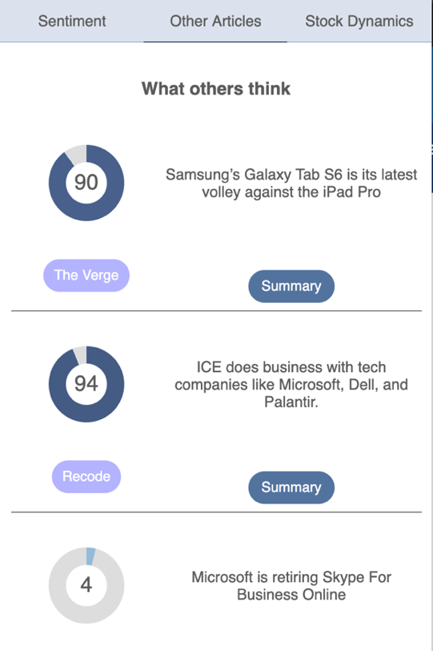

Figure . Other Articles

We decided to use Chart.js to display our charts. We considered other frameworks like Angular.js or Google Charts but decided that they were either too complicated for the task we wanted it to do or too buggy. Using the information gathered by Pandas, we convert the dataframes into strings and integers so that they can be displayed on the graph. We decide if the graph is displayed as red or green, based on if that company’s stock has gone up or down since the start of the year. Displaying the graph using javascript allows the graph to have animations and some level of interactivity. Due to our limited focus, the only interactivity we included was the ability to hover over the graph and receive the exact price of the stock on that day. In the future, we could add extra functionality, like zooming into a particular part of the graph, or choosing a different way for the data to be presented (i.e a candlestick graph, or other similar visual tools), or even choosing between YTD graphs and hourly/weekly/monthly/yearly graphs.

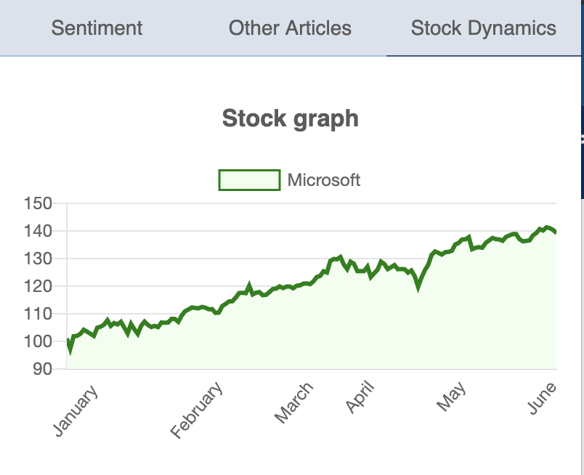

Figure . Stock Graph

# Reflection

We felt as though this project taught us a lot both individually and as a group. We developed better git and version control practices to ensure that everyone had functioning and up to date code. Initially, we all knew bits of frontend development, but every member had the opportunity to expand their knowledge base and learn more. This was especially true since we used raw HTML, CSS, and JavaScript. Finally, we learned about how to manage our own team. We utilized daily standups where we reviewed what each person accomplished yesterday and what they would be focusing on today. A tool we utilized for task structuring is Trello to visualize tasks and make well-organized task lists.

The project has given us insight into the process of developing an end-to-end product. This has given us experiences that we can use to analyze the technologies and methodologies used and critique them. One of the aspects that, if given the chance, we would have done differently is the platform we used to present our user interface. Google Chrome extensions have a lot of unforeseen limitations that stalled and sometimes even halted development. We were unable to be as creative as we wanted because of the limitations. Additionally, we would have wanted to use a more specialized training set for our neural network. We utilized the IMDB training set, however, since our focus is financial news, there is some jargon or nuances that are not included in the movie reviews.

# Conclusion

Our team learned valuable lessons about partner coding, teamwork, development strategies, and new technologies. We have a stronger understanding of machine learning and its capabilities in the real world as well as in the financial industry. While there are many improvements we would have liked to make and certain things we would do differently if we could do it all again, we feel that overall, we benefited greatly from this experience. While we realize that what we have built may not have a big impact, we are still proud to have made it and this experience will make us better employees in the future. We are glad to have had to opportunity to make use of cutting-edge technology and concepts that are on the forefront of innovation, and we are certain that the skills we learned from this project will be of use for us.